**Practical 10**

## Aim: Write a program using AJAX and PHP to demonstrate how a web page can communicate with the web server while a user type characters in input field.

**Code:**

index.php

<style> body{width:50%;}

#frmCheckUsername {border-top:#F0F0F0 2px solid;background:#FAF8F8;padding:10px;}

.demoInputBox{padding:7px; border:#F0F0F0 1px solid; border-radius:4px;}

.status-available{color:#2FC332;}

.status-not-available{color:#D60202;}

</style>

<script src="https://code.jquery.com/jquery-2.1.1.min.js" type="text/javascript"></script>

<script>

function checkAvailability() {

$("#loaderIcon").show(); jQuery.ajax({

url: "check_availability.php", data:'username='+$("#username").val(), type: "POST",

success:function(data){

$("#user-availability-status").html(data);

$("#loaderIcon").hide();

},

error:function (){}

});

}

</script>

<div id="frmCheckUsername">

<label>Check Username:</label>

<input name="username" type="text" id="username" class="demoInputBox" onBlur="checkAvailability()"><span id="user-availability-status"></span>

</div>

<p><img src="LoaderIcon.gif" id="loaderIcon" style="display:none" /></p>

## Code: DBController.php

<?php

class DBController {

private $host = "localhost"; private $user = "root"; private $password = "";

private $database = "studentdatabase2";

function construct() {

$this->conn = $this->connectDB(); if(!empty($this->conn)) {

$this->selectDB();

}

}

function connectDB() {

$conn = mysqli_connect($this->host,$this->user,$this->password,$this->database); return $conn;

}

function selectDB() {

mysqli_select_db($this->conn, $this->database);

}

function numRows($query) {

$result = mysqli_query($this->conn, $query);

$rowcount = mysqli_num_rows($result); return $rowcount;

}

}

?>

## Code: check_availability.php

<?php require_once("DBController.php");

$db_handle = new DBController(); if(!empty($_POST["username"])) {

$query = "SELECT * FROM users WHERE userName='" . $_POST["username"] . "'";

$user_count = $db_handle->numRows($query); if($user_count>0) {

echo "<span class='status-not-available'> Username Not Available.</span>";

}else{

echo "<span class='status-available'> Username Available.</span>";

}

}

?>

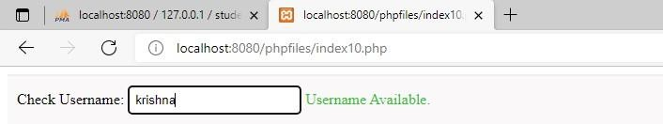

## Output: